Placement data

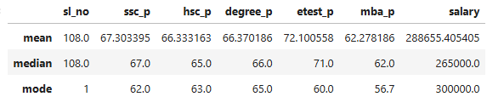

Mean

1. 10th ,12th ,degree, MBA marks total mean was 67,66,66,62 this performance Average
2. But enters test mean 72 this performance good
3. Average students salary 288655

Median

1. 10th ,12th ,degree, MBA marks total Median was 67,65,66,62 this performance Average
2. But enters test mean 71 this performance good
3. Average students salary 265000

Mode

1. 10th ,12th ,degree, MBA, etest Repeat taken this marks 62,63,65,56,60 its mode average
2. 300000 was Repeat salary